
2021 Maryland State Golf Association
Junior Girls Teams

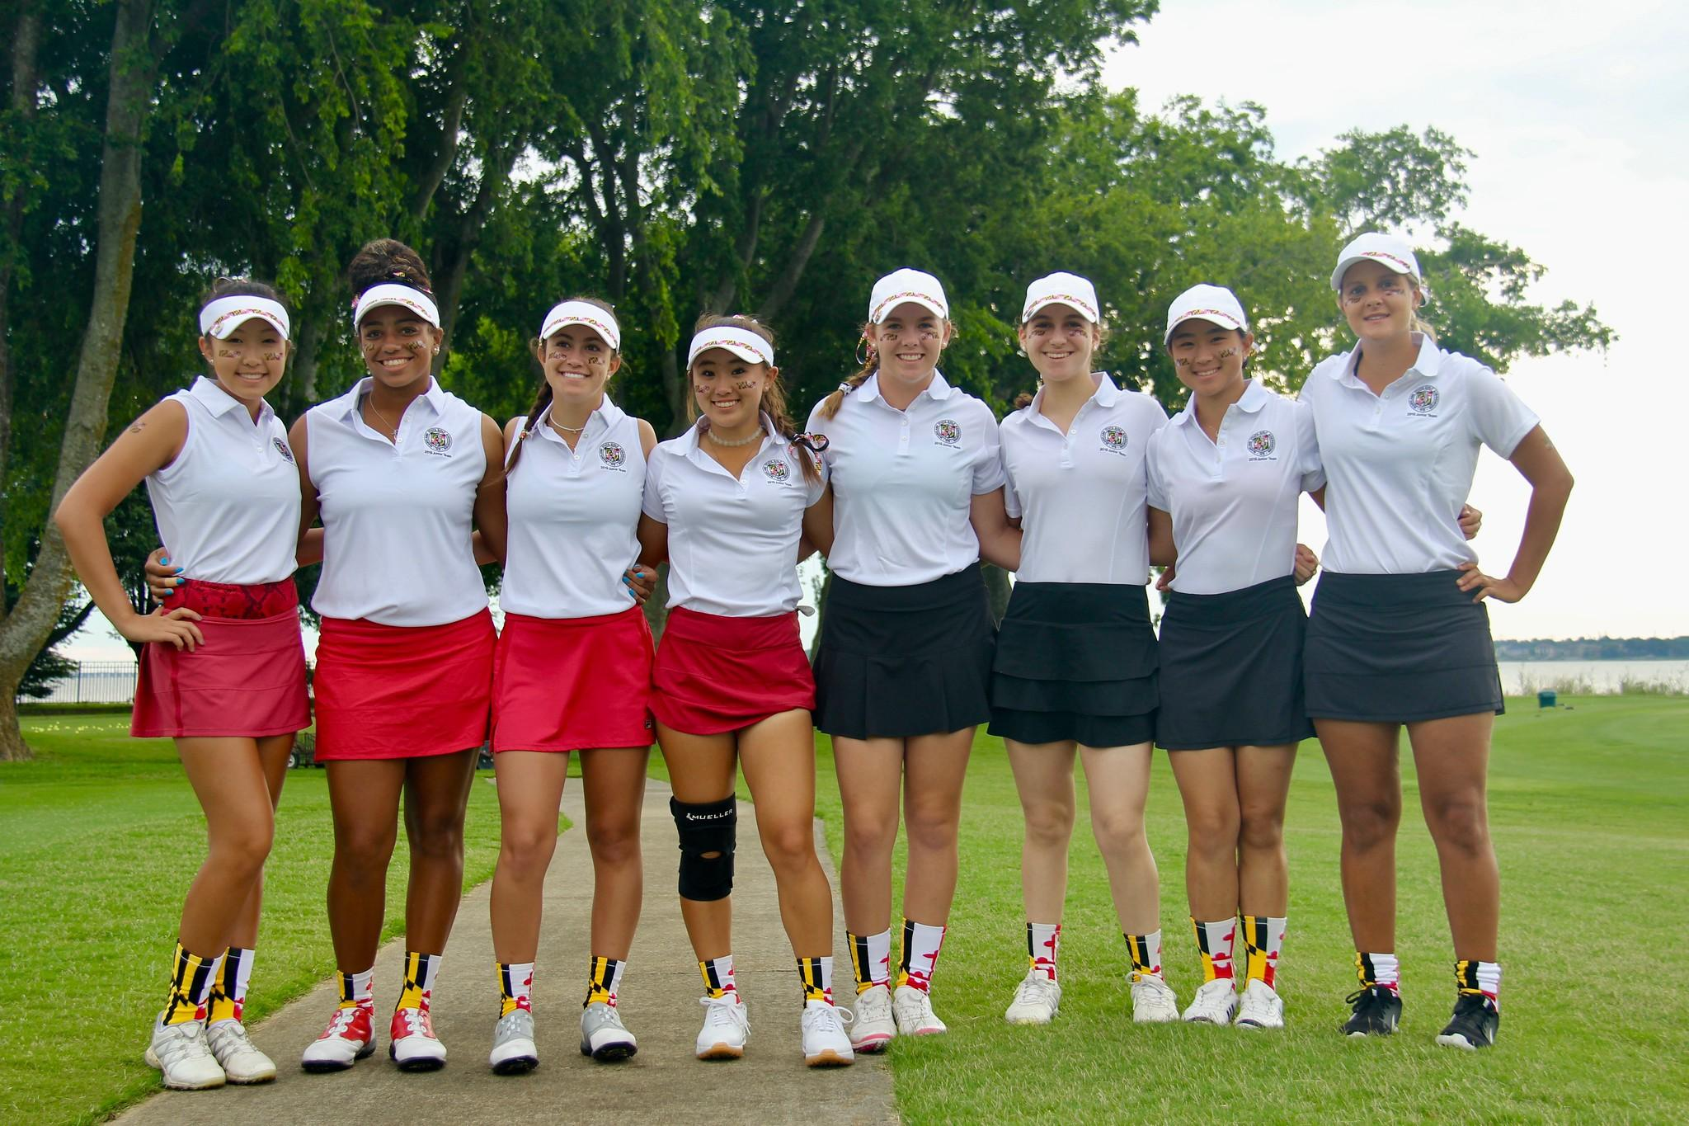

Information & Application Process

Table of Contents
Letter from the Junior Girls Team Captain ……………………………. 3

2021 Eligibility & Selection Process ……………………………………….. 4

2021 Point System & Player Documentation ……..……………….… 5-6

Player Information & Contact Form ………………………………………. 7

Sample Resume ………………………………………………………………………. 8

February 2021
Re: MSGA Junior Girls’ Team Matches & Other Competitions
Dear Young Lady Golfer:

The intent of this letter is to inform you of several important tournaments in the 2021 MSGA schedule. More information for each event will also be available on our website (www.msga.org).

- The Junior Girls Amateur Championship will be held on July 8-9 at The Suburban Club in Pikesville, Maryland. The championship is a two-day, 36-hole stroke play event. Players will compete in 3 age divisions along with crowning a tournament winner and runner-up.
- The Women’s Amateur Championship will be held on July 19-22 at The Elkridge Club in Baltimore, Maryland. An optional 18-hole stroke play qualifying round for the Championship Flight will be conducted on the first day with all players advancing to match play.
- The Poindexter Cup will be held on June 25-27 at Wintergreen Resort in Nellysford, Virginia. INTERESTED JUNIOR GOLFERS MUST SUBMIT A GOLF RESUME IN ORDER TO PARTICIPATE IN THIS EVENT. Eight golfers and 2 alternates will be selected to represent Maryland. More information is listed below.
- The Mid-Atlantic Challenge (MAC) will be held on August 6-8 at Benvenue Golf Course in Rocky Mount, North Carolina. INTERESTED JUNIOR GOLFERS MUST SUBMIT A GOLF RESUME IN ORDER TO PARTICIPATE IN THIS EVENT. Four golfers and 2 alternates will be selected to represent Maryland. More information is listed below.

HOW TO APPLY FOR THE POINDEXTER & MAC:
- Submit just one application to apply for both the Poindexter and MAC
- Although we do not want to discourage anyone from applying, realistically players should have a handicap index of 9.9 or lower, routinely shoot in the low 80’s or better and play in a fair number of tournaments.
- Be sure your handicap is active and up-to-date
- For more details and how to apply, refer to the enclosed documents on eligibility, the selection process and the point system
- Your resume MUST BE SUBMITTED NO LATER THAN MAY 1, 2021
- Submit your resume in 2 ways:
  - Email to bonnie.fry@verizon.net
  - Mailed to Bonnie Fry, 1716 Edwin Drive, Bel Air, Maryland 21015
Sally Ratcliffe will be joining us again this year as the co-captain for both the Poindexter and the MAC and will be the co-chair for the Junior Girls Amateur Championship.

We both look forward to seeing you this coming season. Please do not hesitate to contact me with questions or concerns.

Sincerely,
Bonnie Fry, Captain Junior Girls State Team
1716 Edwin Drive, Bel Air, Maryland 21015
410-937-8516 | bonnie.fry@verizon.net

2021 Eligibility & Selection Process

ELIGIBILITY:
In order to be eligible to play in the Poindexter Cup or the Middle Atlantic Challenge matches, a competitor (junior girl)
- Must have an active handicap established at an MSGA Member Club (facilities are both public and private)
- Must be between the ages of 13-18 (as of May 1, 2021) and not yet be attending college.

SELECTION PROCESS:
- Poindexter Cup Team:
- The team is comprised of 8 Maryland junior girls
- The top 6 players are selected using the point system outlined below
- The next 2 players are Captain’s selections
- The 2-3 alternates are selected using the point system

- The Middle Atlantic Challenge Team:
- The team is typically comprised of 4 Maryland junior girls and 4 Virginia junior girls
- The 4 Maryland players and 2 alternates are Captain’s selections
- The MSGA reserves the right to select fewer than 4 Maryland players in the effort to build a strong Maryland/Virginia team

2021 Point System & Player Documentation
Qualification for the Maryland State Junior Girls’ Golf Team will be based on the following point system. These points will be calculated from tournaments played
January 1, 2019 – December 31, 2020.

- Maryland State Golf Association Championships

MSGA Junior Girls Championship 2020:
FINISH | 1 | 2 | 3 | 4 | 5 | 6 | 7 | 8 | 9 | 10 | 11 | 12 | 13 | 14 | 15 | 16 | 17 | 18 | 19 | 20
POINTS | 300 | 240 | 216 | 192 | 180 | 168 | 156 | 144 | 132 | 120 | 114 | 108 | 102 | 96 | 90 | 84 | 78 | 72 | 66 | 60
FINISH | 21 | 22 | 23 | 24 | 25 | 26 | 27 | 28 | 29 | 30 | 31 | 32 | 33 | 34 | 35 | 36 | 37 | 38 | 39 | 40
POINTS | 57 | 54 | 51 | 48 | 45 | 42 | 39 | 36 | 33 | 30 | 27 | 24 | 21 | 18 | 15 | 12 | 9 | 6 | 3 | 0

MSGA Junior Girls Championship 2019:
FINISH | 1 | 2 | 3 | 4 | 5 | 6 | 7 | 8 | 9 | 10 | 11 | 12 | 13 | 14 | 15 | 16 | 17 | 18 | 19 | 20
POINTS | 200 | 160 | 144 | 128 | 120 | 112 | 104 | 96 | 88 | 80 | 76 | 72 | 68 | 64 | 60 | 56 | 52 | 48 | 44 | 40
FINISH | 21 | 22 | 23 | 24 | 25 | 26 | 27 | 28 | 29 | 30 | 31 | 32 | 33 | 34 | 35 | 36 | 37 | 38 | 39 | 40
POINTS | 38 | 36 | 34 | 32 | 30 | 28 | 26 | 24 | 22 | 20 | 18 | 16 | 14 | 12 | 10 | 8 | 6 | 4 | 2 | 0

MSGA Women’s Amateur Championship 2020:
Qualifying Round
FINISH | 1 | 2 | 3 | 4 | 5 | 6 | 7 | 8 | 9 | 10 | 11 | 12 | 13 | 14 | 15 | 16 | 17 | 18 | 19 | 20
POINTS | 300 | 240 | 216 | 192 | 180 | 168 | 156 | 144 | 132 | 120 | 114 | 108 | 102 | 96 | 90 | 84 | 78 | 72 | 66 | 60
FINISH | 21 | 22 | 23 | 24 | 25 | 26 | 27 | 28 | 29 | 30 | 31 | 32 | 33 | 34 | 35 | 36 | 37 | 38 | 39 | 40
POINTS | 57 | 54 | 51 | 48 | 45 | 42 | 39 | 36 | 33 | 30 | 27 | 24 | 21 | 18 | 15 | 12 | 9 | 6 | 3 | 0
In addition:
- Overall Champion will receive 30 points
- Overall Runner-Up and Flight Winners will receive 20 points

MSGA Women’s Amateur Championship 2019:
Qualifying Round
FINISH | 1 | 2 | 3 | 4 | 5 | 6 | 7 | 8 | 9 | 10 | 11 | 12 | 13 | 14 | 15 | 16 | 17 | 18 | 19 | 20
POINTS | 200 | 160 | 144 | 128 | 120 | 112 | 104 | 96 | 88 | 80 | 76 | 72 | 68 | 64 | 60 | 56 | 52 | 48 | 44 | 40
FINISH | 21 | 22 | 23 | 24 | 25 | 26 | 27 | 28 | 29 | 30 | 31 | 32 | 33 | 34 | 35 | 36 | 37 | 38 | 39 | 40
POINTS | 38 | 36 | 34 | 32 | 30 | 28 | 26 | 24 | 22 | 20 | 18 | 16 | 14 | 12 | 10 | 8 | 6 | 4 | 2 | 0
In addition:
- Overall Champion will receive 15 points
- Overall Runner-Up and Flight Winners will receive 10 points
MSGA Open Championship 2020:
FINISH | 1 | 2 | 3 | 4 | 5 | 6 | 7 | 8 | 9 | 10 | 11 | 12 | 13 | 14 | 15 | 16 | 17 | 18 | 19 | 20
POINTS | 300 | 240 | 216 | 192 | 180 | 168 | 156 | 144 | 132 | 120 | 114 | 108 | 102 | 96 | 90 | 84 | 78 | 72 | 66 | 60
FINISH | 21 | 22 | 23 | 24 | 25 | 26 | 27 | 28 | 29 | 30 | 31 | 32 | 33 | 34 | 35 | 36 | 37 | 38 | 39 | 40
POINTS | 57 | 54 | 51 | 48 | 45 | 42 | 39 | 36 | 33 | 30 | 27 | 24 | 21 | 18 | 15 | 12 | 9 | 6 | 3 | 0

MSGA Open Championship 2019:
FINISH | 1 | 2 | 3 | 4 | 5 | 6 | 7 | 8 | 9 | 10 | 11 | 12 | 13 | 14 | 15 | 16 | 17 | 18 | 19 | 20
POINTS | 200 | 160 | 144 | 128 | 120 | 112 | 104 | 96 | 88 | 80 | 76 | 72 | 68 | 64 | 60 | 56 | 52 | 48 | 44 | 40
FINISH | 21 | 22 | 23 | 24 | 25 | 26 | 27 | 28 | 29 | 30 | 31 | 32 | 33 | 34 | 35 | 36 | 37 | 38 | 39 | 40
POINTS | 38 | 36 | 34 | 32 | 30 | 28 | 26 | 24 | 22 | 20 | 18 | 16 | 14 | 12 | 10 | 8 | 6 | 4 | 2 | 0

- AJGA Tournaments:
  - 1st Place: 25 points
  - 2nd Place: 20 points
  - 3rd Place: 15 points
  - 4th Place thru 10th Place: 10 points
  - 11th Place thru 20th Place: 5 points

- USGA Tournaments: Includes USGA Junior Girls’, USGA Women’s Open, and USGA Women’s Amateur
  - Champion: 50 points
  - Runner-Up: 35 points
  - Semi-Finals: 30 points
  - Quarter-Finals: 25 points
  - Qualify for Match Play: 20 points
  - Qualify for Tournament: 15 points

- Other Tournaments: Please list the other significant tournaments played (tournament names, dates, scores, course names and locations, yardages played, finishes and number of participants). This information and current USGA Handicap index may be used for the purpose of the captain’s selections.

Player Documentation:
If you would like to be considered for the Junior Girls’ Team Matches please submit the following information before MAY 1 to BONNIE FRY via either email (bonnie.fry@verizon.net) or US Mail (1716 Edwin Drive, Bel Air, MD 21015)
- Resume (see sample resume) - Must include your name; address; telephone numbers; e-mail address; date of birth; club or facility affiliation; current USGA handicap index; and the tournament names, dates, scores, course names and locations, yardages played, finishes and number of participants of all major tournaments played during 2019-2020.
- Player Information Form (see MSGA – 2021 JUNIOR GIRLS’ TEAMS - Player Information & Contact Form)

2021 Player Information & Contact Form
(Please return this form with your resume to Bonnie Fry at bonnie.fry@verizon.net)

PLAYER CONTACT INFORMATION:
NAME:
DATE OF BIRTH:
HOME ADDRESS:
YOUR CELL PHONE #:
YOUR HOME PHONE #:
YOUR EMAIL ADDRESS:
CLUB AFFILIATION:
UNIFORM (circle your selection):
SHIRT: Short sleeves or Sleeveless
SHIRT SIZE: XS, Small, Medium, Large or XL
GOLF SKORT SIZE: XS, Small, Medium, Large or XL
HAT: Cap or Visor
PARENT/GUARDIAN INFORMATION:
PARENT/GUARDIAN #1 RELATIONSHIP:
NAME:
CELL PHONE #:
EMAIL ADDRESS:
PARENT’S/GUARDIAN #2 RELATIONSHIP:
NAME:
CELL PHONE #:
EMAIL ADDRESS:
EMERGENCY CONTACT PERSON(S):
NAME(S):
RELATIONSHIP(S):
PHONE NUMBER(S):
HEALTH ISSUES: (Are there any issues the Captains should be aware of while you are away from home? This information will remain confidential!)
Sample Resume
Name: Email:
Address: Date of Birth:
Cell Phone #: Home Phone #:
Club Affiliation: USGA Handicap Index:

1. Maryland State Golf Association Championships:
SCORE(S) DATE NAME OF TOURNAMENT FINISH POINTS
77-78 August 11-12, 2020 MSGA Junior Girls’ Championship 5th Place 180
Blue Mash Golf Course, Laytonsville, MD

78-81 June 17-18, 2019 MSGA Junior Girls’ Championship 8th Place 96
Green Spring Valley Hunt Club, Owings Mills, MD

?? July 13-16, 2020 MSGA Women’s Amateur Championship 17th Place 78
P.B. Dye Golf Club, Ijamsville, MD
(Qualifying Round)
Overall Champion: YES/NO 0
Runner Up and Flight Winners: YES/NO 20

?? July 22-25, 2019 MSGA Women’s Amateur Championship T23 Place 80
Norbeck Country Club, Rockville, MD
(Qualifying Round)
Overall Champion: YES/NO 0
Runner Up and Flight Winners: YES/NO 20

78-78 October 13-14, 2020 MSGA Women’s Open Championship 20th Place 60
Baltimore Country Club (East), Lutherville, MD

82-86 July 29-30, 2019 MSGA Women’s Open Championship 29th Place 22
Caves Valley Golf Club, Owings Mills, MD

2. AJGA Tournaments:
SCORE(S) DATE NAME OF TOURNAMENT FINISH POINTS
YARDAGE PLAYED COURSE AND LOCATION SIZE OF FIELD
75-75-36-36 August 10-13, 2020 AJGA UHY/TFT Baltimore Jr. 3rd Place 15
Yardage: 5,000 Hillendale Country Club, Phoenix, MD (Field of 27)

3. USGA Tournaments:
SCORE(S) DATE NAME OF TOURNAMENT FINISH POINTS
YARDAGE PLAYED COURSE AND LOCATION SIZE OF FIELD
77-74 August 3-9, 2020 USGA Women’s Amateur 74th Place 15
Yardage: 6,000 Hillendale Country Club, Phoenix, MD (Field of 132)

4. Other Tournaments:
SCORE(S) DATE NAME OF TOURNAMENT FINISH
YARDAGE PLAYED COURSE AND LOCATION SIZE OF FIELD
72-78 April 13-14, 2019 Peggy Kirk Bell – Mid-Atlantic 2nd Place
Yardage: 5,750 Havre de Grace, MD (Field of 27)

